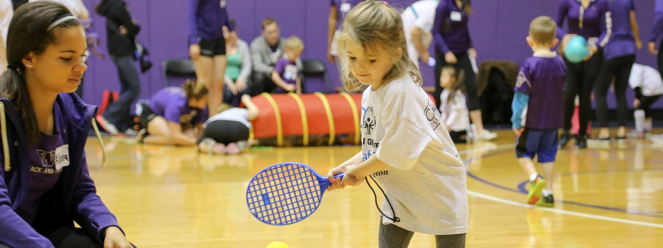
(Season) Schedule

Young Athletes™ (insert site name)
Young Athletes™ (YA) is an inclusive sports program for children 2 -7 with and without intellectual or developmental disabilities. It’s comprised of research based activities that build social and motor skills while engaging young children of all abilities.
Practices will be held from (time) at (location and address)

July 26 9:00-10:00 am
July 29: 9:00-10:00 am
August 1: 9:00-10:00 am
August 5: 9:00-10:00 am
August 9: 9:00-10:00 am
August 12: 9:00-10:00 am
August 16 : 9:00-10:00 am
August 19: 9:00-10:00 am

Email (site coordinator name) at (email) to sign up.

